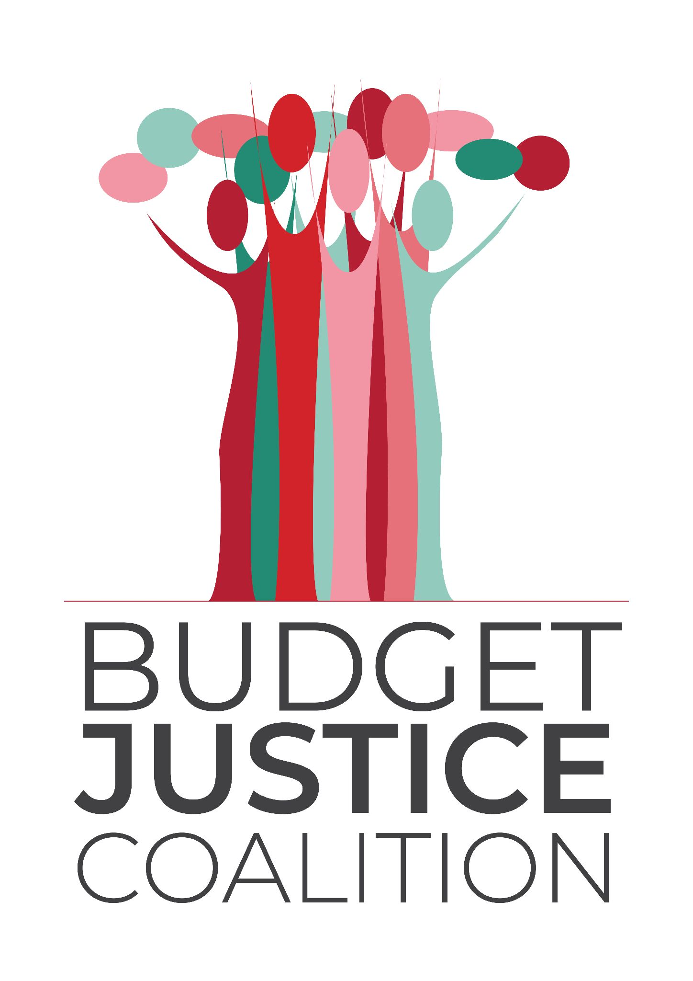

**MEDIA STATEMENT  
FOR IMMEDIATE RELEASE  
26 May 2025**

**Budget Justice Coalition warns Budget 3.0 is a step forward but not far enough**

The Budget Justice Coalition (BJC) welcomes the shift in Budget 3.0 towards modest real investment in social spending, with non-interest expenditure set to grow by 0.8% in real terms - the first such increase since the onset of the COVID-19 pandemic, but warns about downward revisions to key social spending allocations compared to earlier versions of the 2025/26 budget.

In our submission to the Financial Committee, the BJC has highlighted the missed opportunities and regressive choices made on the revenue side of the budget, and highlighted spending gaps in health, education, social protection and youth unemployment. ‘This is a **trade-off that could have been avoided** had Treasury pursued the progressive revenue alternatives repeatedly proposed by civil society’, says [Matshidiso Lencoasa](https://www.linkedin.com/in/matshidiso-lencoasa-82119578/overlay/about-this-profile/), chairperson of the BJC.

While the reversal of the VAT hike is welcome, the decision to increase the fuel levy by 16c per litre is deeply regressive and risks eroding gains, particularly for low-income households already burdened by rising costs. Budget 3.0 still falls short of a truly transformative, redistributive, and pro-poor fiscal framework.

**Revenue: Missed Opportunities and Regressive Choices**

We are concerned that the National Treasury closed the door on progressive revenue options, even after extensive civil society engagement. Instead of taxing wealth, high incomes, excess corporate profits or even leveraging existing state surpluses, Treasury has chosen to increase the general fuel levy by 16c per litre (15c for diesel) to partially plug the R61.9 billion revenue gap left by the VAT hike reversal and lower growth projections. ‘It is unclear whether the potential impacts of this measure have been considered, or whether the risks have been weighed up against the potential revenue gain of approximately R4 billion in 2025/26’, adds Lencoasa.

This decision is regressive as it will:

1. Increase transport costs for poor and working-class households.
2. Raise the price of food and other essential goods and services, especially in rural and peri-urban areas.
3. Undermine social programmes like the National School Nutrition Programme, where logistics and delivery costs will rise.
4. Increase the cost of looking for work, placing further pressure on the unemployed

‘At the BJC, we reject the idea that poor and working-class South Africans must continue to carry the fiscal burden while Treasury ignores well-evidenced proposals. The choice to raise revenue regressively is a political one, not a fiscal necessity’ adds Lencoasa.

While the Minister’s announcement that new tax measures will be considered for 2026, we call for progressive choices, and an open, transparent consultation process that includes all stakeholders and is informed by evidence, equity, and social justice.

### **Spending: A Mixed Picture**

While non-interest expenditure is set to grow at an average of 5.4% over the medium term, real growth sits at just 0.8%, far below what is needed to restore eroded public services or respond to growing demand. On closer examination, our analysis reveals that spending decreases in 2026/27 and 2027/28, so spending pressures have not been adequately addressed. Furthermore, when we consider per capita spending in health and education, the real increases fall away.

#### **Health**

For the first time since the COVID-19 pandemic, the health budget sees a real increase, rising to R296 billion in 2025/26. However, behind this welcome headline lies a tougher truth: per person, government is spending less on health than before, and critical programmes are still being cut. Per health care user spending rises to R5 460.71 per healthcare user in nominal terms, but a reduced R5 053.50 in real terms. Funding for HIV & AIDS drops by 3.1% in real terms in a context where USAID PEPFAR funding has been pulled from the sector, and while Emergency Medical Services is also reduced by 2.4% after accounting for inflation. The withdrawal of donor support from 27 high-burden districts, coupled with government inaction, risks reversing hard-won progress. TB, the country’s biggest killer, continues to claim 56,000 lives a year - mostly Black and poor South Africans - yet the resources to find and treat cases are falling short. ‘This needs urgent reinvestment and a public expenditure strategy that puts health and dignity at the centre’ adds Lencoasa.

#### **Education**

After years of chronic underfunding and real-term cuts, basic education finally receives a boost — a 6.7% nominal increase to R347 billion in 2025/26, or 2.6% in real terms, marking the largest rise since 2022/23. But even this is not enough to reverse years of neglect. Per learner spending continues to fall in real terms, dropping to R23,755.34, placing even more pressure on overcrowded classrooms, crumbling infrastructure, and overburdened teachers. Early Childhood Development sees a long-overdue 17.7% real increase, with the per-child subsidy rising from R17 to R24 per day — a hopeful step toward giving every child a stronger start in life. Infrastructure funding also rises by 4.9% in real terms to R15.2 billion, a critical intervention to restore safe and functional learning environments. ‘These gains are fragile. They must be shielded from underspending, matched to real demand, and signal a deeper commitment to rebuilding public education and ending the cycle of intergenerational poverty’ says Lencoasa.

#### **Social Protection**

Since Budget 1.0, planned social grant increases have dropped by 93% — from R23.2 billion to just R1.6 billion. Worse, no inflation-related increases are proposed for 2026/27 and 2027/28, with R1.3 billion and R5.3 billion cut from the Child Support Grant and Old Age Pension, respectively. In a concerning move, Treasury is pressuring SASSA to apply means tests — originally used for the COVID-SRD grant and recently declared unconstitutional — to all social grants. SASSA must now report quarterly on grants cancelled and savings achieved, incentivising under-spending and artificially deflating beneficiary numbers. This risks enabling deeper cuts in future budgets without transparent public disclosure.

#### **Youth Unemployment**

Youth unemployment remains a national emergency, with half of young people between the ages of 15 and 35 unemployed. Government’s response remains inadequate. Public Employment Programmes such as the Presidential Youth Employment Initiative have demonstrated impact, but their funding remains insecure. ‘We welcome that the programme funding has been confirmed for 2025 and encourage such initiatives to be scaled rather than being sidelined’ adds Lencoasa.

### **The budget falls short of a true People's Budget**

Budget 3.0 offers welcome relief through the VAT reversal and modest real increases in basic services, but it falls short of a truly pro-poor, justice-driven agenda. Deep cuts, weak buffers, and a failure to consider progressive revenue options reveal that public inputs have been sidelined. Furthermore, without stronger oversight and anti-corruption measures, especially provincially, these gains risk being lost. With growth projections downgraded, government must align industrial, fiscal, and monetary policy to spur inclusive growth and expand the tax base.

In the upcoming Fiscal Framework hearings, the BJC will present concrete proposals to strengthen equity, sustainability, and impact. A just budget must centre people, rights, and long-term resilience.

**For media enquiries:**

To arrange interviews with BJC representatives, contact Clotilde Angelucci [clotilde@youthcapital.co.za](mailto:clotilde@youthcapital.co.za)/ 0826815927

**[ENDS]**

**ABOUT THE BUDGET JUSTICE COALITION:**

The organisations that make up the BJC are: Alternative Information and Development Centre (AIDC), the Children’s Institute at UCT (CI), Corruption Watch (CW), Equal Education (EE), Equal Education Law Centre (EELC), HEALA, the Institute for Economic Justice (IEJ), Oxfam SA, Pietermaritzburg Economic Justice and Dignity Group (PMEJD), the Public Service Accountability Monitor (PSAM), the Rural Health Advocacy Project (RHAP), SECTION27, Ilifa Labantwana, Treatment Action Campaign (TAC), the Legal Resources Centre (LRC), Centre for Child Law (CCL), Youth Capital, 350.org, Open Secrets, Public Affairs Research Institute (PARI), Amandla.mobi, Black Sash, My Vote Counts as well as friends of the coalition.

The purpose of the Budget Justice Coalition is to collaboratively build people’s understanding of and participation in South Africa’s planning and budgeting processes – placing power in the hands of the people to ensure that the state advances social, economic and environmental justice, to meet people’s needs and wellbeing in a developmental, equitable and redistributive way.